Forecasting Weekly and Hourly German Electricity Demand
A comparative evaluation of statistical, machine-learning and deep-learning forecasting models
Advanced Research Topics — Assignment 1

Code: https://colab.research.google.com/drive/125aoZ03-P6ZcTBXtX10AiKe8aAe3Iw66
GitHub Link: https://github.com/kakarlarenusree/Time-Series-Modelling-Case-Study_Renu
Data: Open Power System Data (Germany, hourly, 2015-01-01 to 2020-09-30) with Berlin temperature from Open-Meteo
1. Introduction and objectives
This report documents the modelling, forecasting and critical evaluation carried out in the accompanying notebook on German national electricity demand. Hourly load figures from Open Power System Data (1 Jan 2015 – 30 Sep 2020, 50,400 observations) were aggregated to weekly means (GW) for classical modelling, while hourly resolution was retained for the LSTM. Daily Berlin temperature (Open-Meteo) was used throughout as a weather proxy and explanatory variable.
Eight models were compared on a common 104-week hold-out (14 Oct 2018 – 4 Oct 2020): four benchmarks (Mean, Naive, Seasonal Naive, Drift), a grid-searched SARIMA, a SARIMAX with temperature/holiday regressors, a feature-engineered Gradient Boosting Regressor (GBR), and an hourly LSTM. A recurring theme runs through the analysis: models differ substantially in how much true, recent information they are allowed to “see” at forecast time, and this difference in task difficulty — not just raw modelling power — explains much of the final scoreboard. Section 9 answers six set questions on leakage, specification, covariates, interpretability and operational recommendation, drawing on Sections 2–8.
2. Exploratory data analysis
Figure 1 shows hourly, daily and weekly resolutions. Averaging removes intraday/weekday cycling and reveals a strong annual seasonal cycle (winter peak, summer trough), a mild 2015–2020 downward trend, and the sharp COVID-19 demand shock of spring 2020.
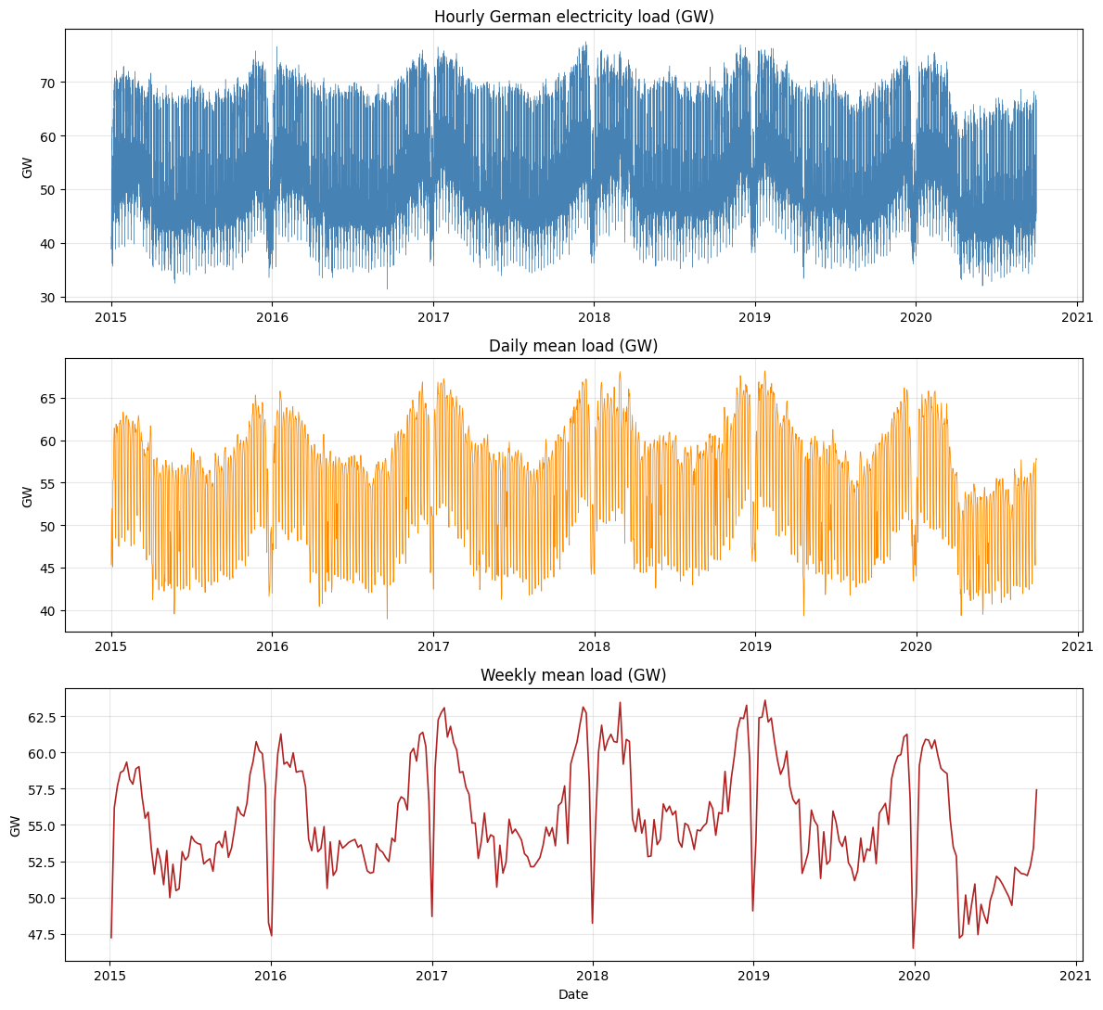
Figure 1. German load at hourly, daily and weekly resolution, 2015–2020.
The weekly boxplot-by-ISO-week (Figure 2) confirms a broad winter peak, a summer trough and a sharp Christmas/New-Year collapse recurring reliably enough that a model exploiting last year's same week (Seasonal Naive) should do well.
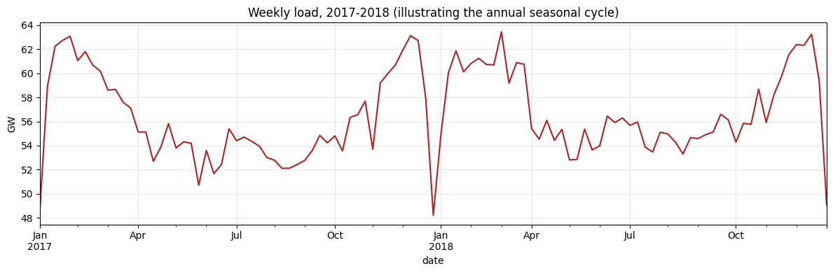 | 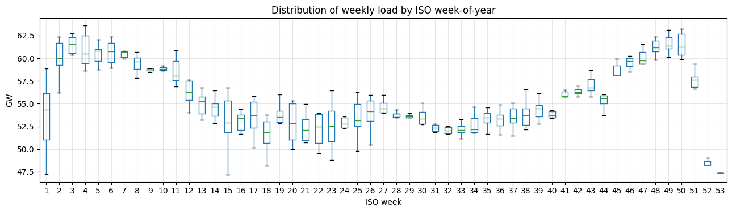
Figure 2. Weekly load, 2017–2018 (left) and distribution by ISO week-of-year (right).
2.1 Decomposition and stationarity
An STL decomposition (period 52, robust) was preferred over classical decomposition because it tolerates holiday/COVID outliers and lets the seasonal shape drift slightly. Strength-of-trend was 0.383 and strength-of-seasonality 0.871 (Hyndman & Athanasopoulos, 2021) — the annual cycle is the dominant, highly predictable structure, foreshadowing that any model exploiting the 52-week cycle starts from a strong position.
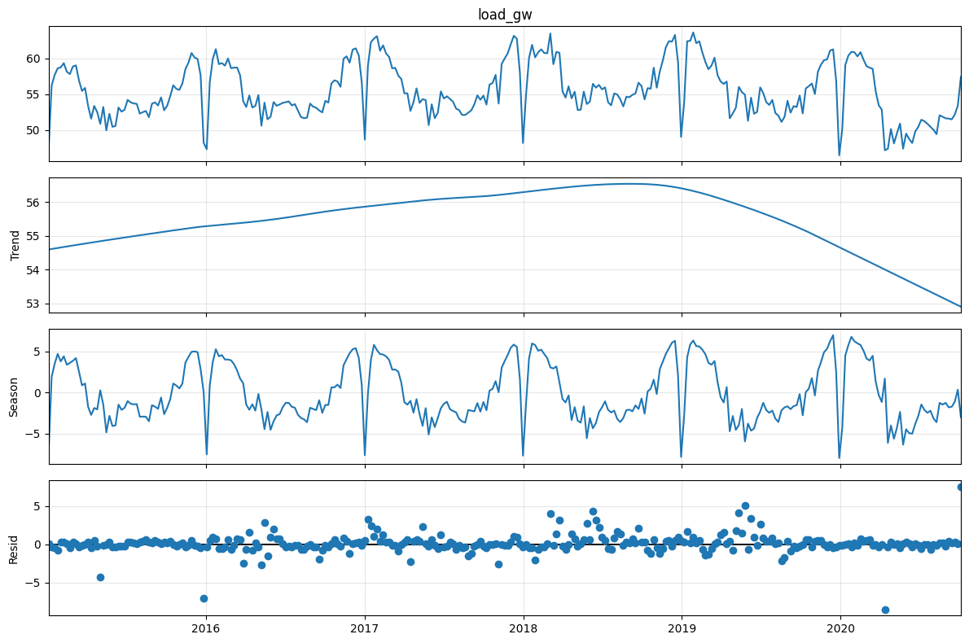
Figure 3. STL decomposition of the weekly series.
ADF and KPSS tests agreed the level series is already stationary in the classical sense (ADF = −4.047, p = 0.0012; KPSS = 0.160, p > 0.10), before and after differencing. This does not contradict the STL seasonality finding: ADF/KPSS test only for a regular unit root, not a seasonal one — the annual cycle visible in STL and the slow 52-week ripple in the ACF (Figure 4) is invisible to these tests. No first-differencing is needed to fix a stochastic trend, but the tests give no guidance on whether a seasonal difference (D = 1) is warranted; that was left to the AIC grid search in Section 4, with consequences discussed below.
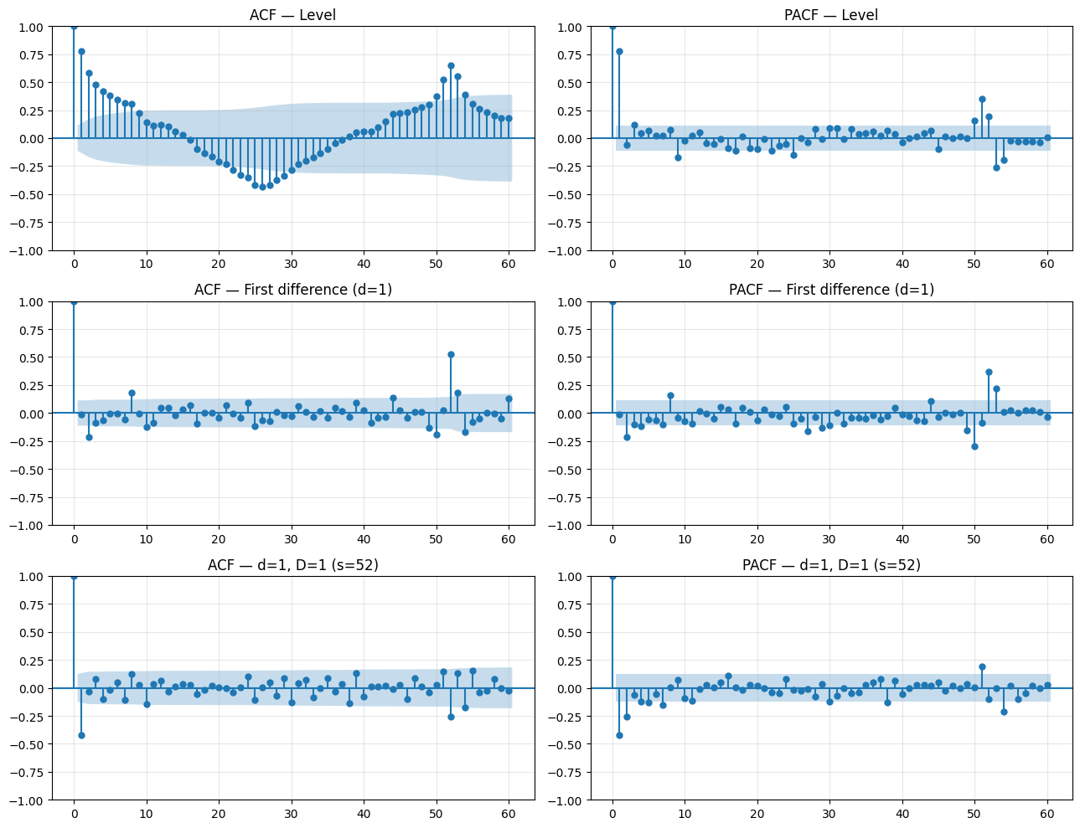
Figure 4. ACF/PACF at level, after first differencing, and after first + seasonal differencing.

3. Benchmark forecasts
Four benchmarks were fitted on a 197-week training set (4 Jan 2015 – 7 Oct 2018) and evaluated on the 104-week test set. Full metrics are in Table 1 (Section 8).
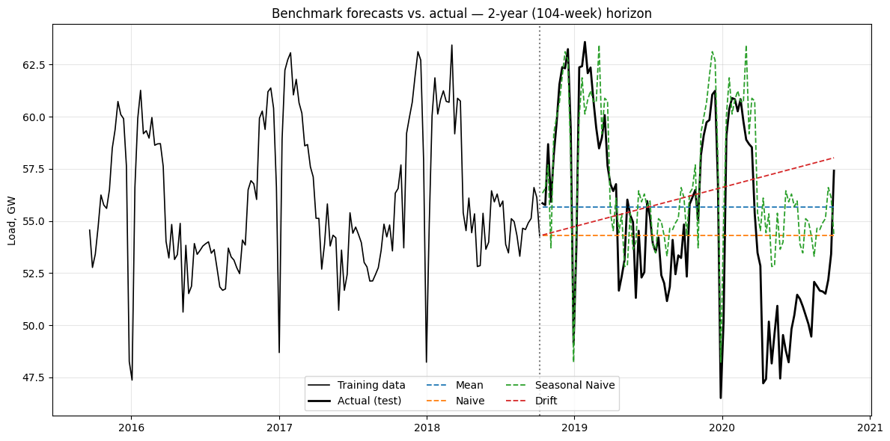
Figure 5. Benchmark forecasts vs. actual load over the two-year test period.
Seasonal Naive clearly dominates (MAE 2.32 GW vs. 3.78–4.34 GW for the rest) since it alone reuses the annual cycle; Mean, Naive and Drift drift or flatten badly over a two-year horizon. Seasonal Naive, not zero error, is therefore the relevant bar for judging whether more sophisticated models earn their added complexity.
4. SARIMA: grid search, diagnostics, forecast
Since ADF/KPSS could not inform D, the AIC grid search was allowed to select d and D itself, split into a non-seasonal stage (p,d,q with seasonal order fixed at (1,1,1)₅₂) followed by a seasonal stage. Stage 1 selected (p,d,q) = (3,1,6), AIC = 303.36 (144/147 candidates converged, ≈80 min). Stage 2 selected (P,D,Q) = (0,2,2) with AIC = 24.00 — over an order of magnitude lower than any competitor, and BIC returned NaN: a warning sign confirmed when fitting showed every coefficient with standard error ≈ 0 and z-statistic ±∞, with statsmodels flagging a singular covariance matrix.
This is the classic over-differencing signature: a second seasonal difference at lag 52 discards 104 of 197 weekly points before estimation, leaving ≈93 effective observations for an 11-parameter structure — few enough that the optimiser drives the likelihood to a near-perfect, numerically degenerate fit that AIC rewards despite it having nothing to do with genuine predictive skill. Recomputed residual diagnostics gave Ljung-Box p = 0.020, 0.257 and 2.8×10⁻¹⁰ at lags 10, 20, 52 — significant autocorrelation remains at the seasonal lag despite double seasonal differencing, i.e. the degenerate fit captured noise in the truncated window rather than the genuine annual cycle.
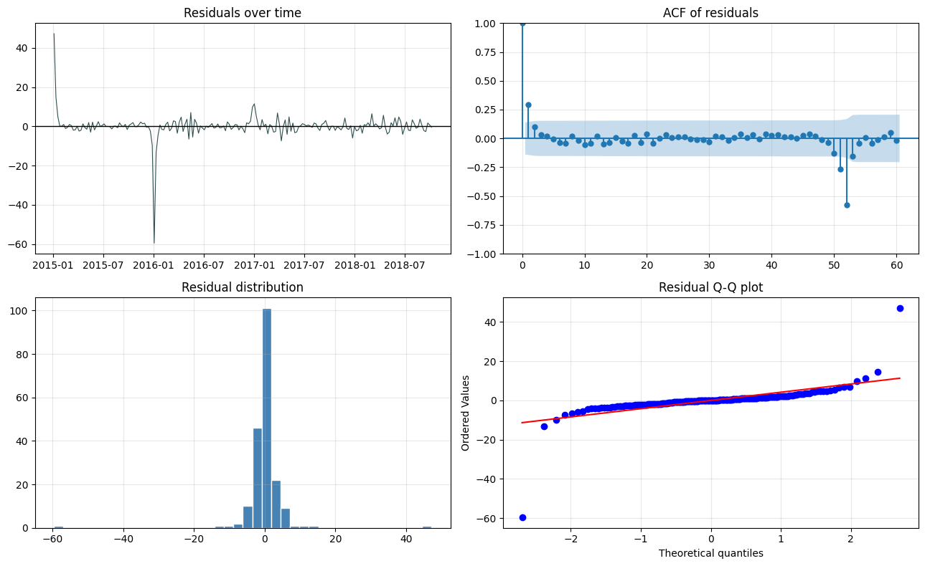 | 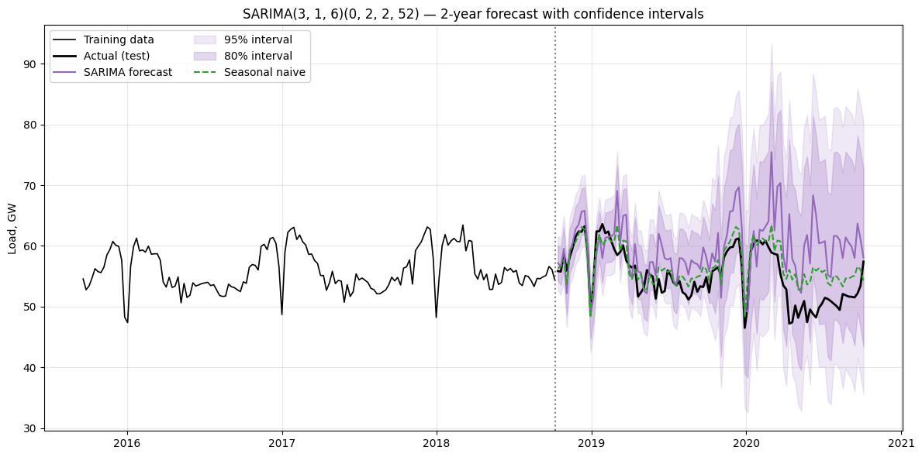
Figure 6. SARIMA(3,1,6)(0,2,2)₅₂ residual diagnostics (left) and forecast with 80%/95% CIs vs. actual and Seasonal Naive (right).
The point forecast drifts increasingly from the actual series as the horizon lengthens, and the CI band widens to compensate — a symptom of a poorly-conditioned, noise-fitted model. Test-set RMSE = 6.622 GW, MAE = 5.089 GW, MASE = 3.802 — worse than every naive benchmark including the trivial Mean. An automated, seemingly rigorous AIC search run exactly as specified produced the worst model in the comparison, because its search space included differencing orders inappropriate for ∼3.8 years of training data. A more defensible search would cap D at 1, or discard candidates with singular covariance matrices.
5. SARIMAX with temperature and holiday regressors
Weekly mean/min/max Berlin temperature, heating/cooling degree-days (base 15.5°C/22°C) and a German public-holiday count were added as exogenous regressors to the same (3,1,6)(0,2,2)₅₂ order. The temperature values used across the test period are the actually-observed values, not values forecast in advance — so this is a conditional (“what would demand have been, given how the weather turned out”) rather than a genuinely operational forecast.
Fitted coefficients: temp_mean = 0.289, heating-degree-days = 0.063, cooling-degree-days = −0.103 (holiday terms collapsed to zero, another symptom of the near-singular estimation). The positive heating coefficient is intuitive; the negative cooling coefficient is not — in a system with limited air-conditioning such as Germany's, cooling-degree-days also mark summer holiday weeks when demand falls independently of temperature, so the coefficient plausibly reflects a confound a purely statistical regression cannot disentangle without holiday×degree-day interactions.
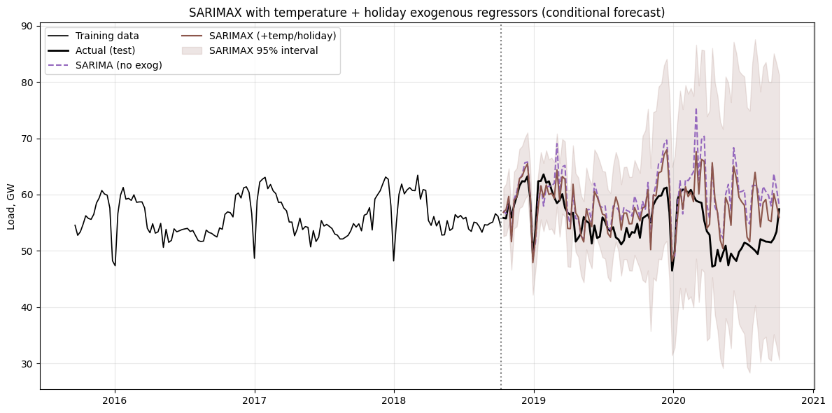
Figure 7. SARIMAX (temperature + holiday) forecast vs. SARIMA and actual load.
Adding exogenous variables reduced test RMSE from 6.622 GW to 5.446 GW — a genuine improvement confirming weather carries real explanatory information — but 5.446 GW remains far worse than Seasonal Naive (3.007 GW), since the degenerate ARMA structure inherited from Section 4 still shapes most of the forecast path. Better features cannot fully compensate for a broken core specification; diagnosing the specification problem is more valuable than iterating on features.
6. Feature-based regression (Gradient Boosting)
The problem was reframed as supervised learning: a HistGradientBoostingRegressor (500 iterations, learning rate 0.03, max 15 leaves, L2 = 0.1) was trained on 26 features — seven load lags (1,2,4,8,13,26,52 weeks), rolling means/std, calendar Fourier terms, and the Section 5 temperature/holiday features. Two leakage traps were avoided: lag/rolling features used shift(1) before any rolling window (week t's features use only data up to t−1), and a single chronological split was used throughout.
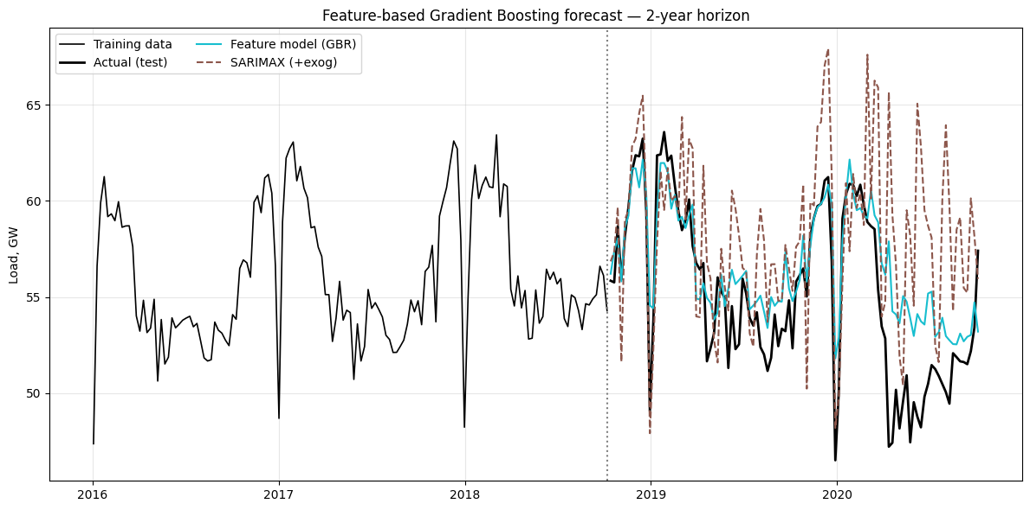 | 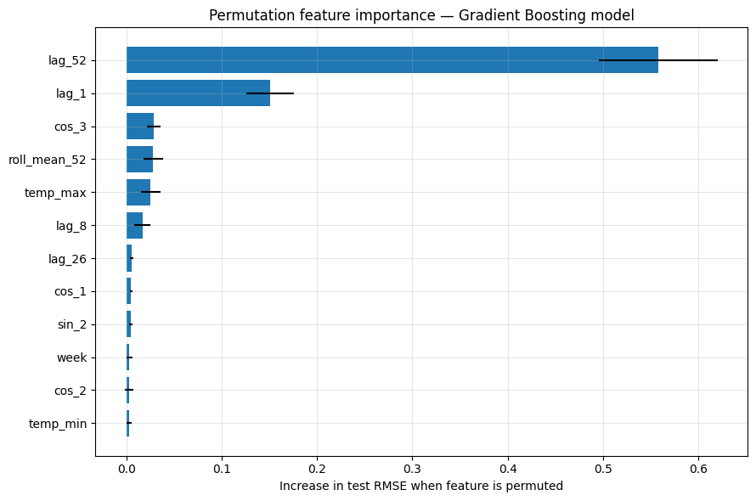
Figure 8. Gradient Boosting forecast vs. SARIMAX and actual (left); permutation feature importance (right).
GBR achieved RMSE = 2.724 GW, MAE = 2.003 GW, MASE = 1.453 — better than every classical model. This needs care in interpretation: SARIMA/SARIMAX commit to one uninterrupted 104-week forecast, whereas GBR's lag features were built from the true, fully-observed load series, so at every test point the model has access to real load from one, two, four+ weeks earlier — effectively re-run weekly with fresh information rather than compounding its own errors over two years. This easier task explains much of GBR's advantage, independent of modelling sophistication.
Permutation importance shows lag_52 dominates (0.558), lag_1 a distant second (0.151), with temperature/calendar/rolling terms all under 0.03 — the model has essentially rediscovered Seasonal Naive as its primary strategy plus a small short-term correction, consistent with the STL seasonality strength of 0.871. “Machine learning model” somewhat overstates how much new structure GBR discovers beyond the seasonal-naive baseline it beats.
7. Hourly LSTM model
LSTMs (Hochreiter & Schmidhuber, 1997) use gated memory to avoid vanishing gradients, suiting load data with structure at multiple timescales. Prior work (Kong et al., 2019) finds LSTMs competitive with classical models at hour/day-ahead horizons since networks learn non-linear calendar/weather interactions without a specified functional form; feature-augmented hybrids (Bouktif et al., 2018) push this further.
A sequence-to-sequence LSTM was trained on the hourly series (168-hour lookback, 24-hour horizon) on scaled load, temperature and sine-cosine calendar features, scaling fit on training data only. A small grid selected 64 hidden units, 1 layer, dropout 0.2 (validation MSE 0.0307), trained with early stopping and rolled forward in 24-hour blocks using genuinely known-at-origin inputs each step.
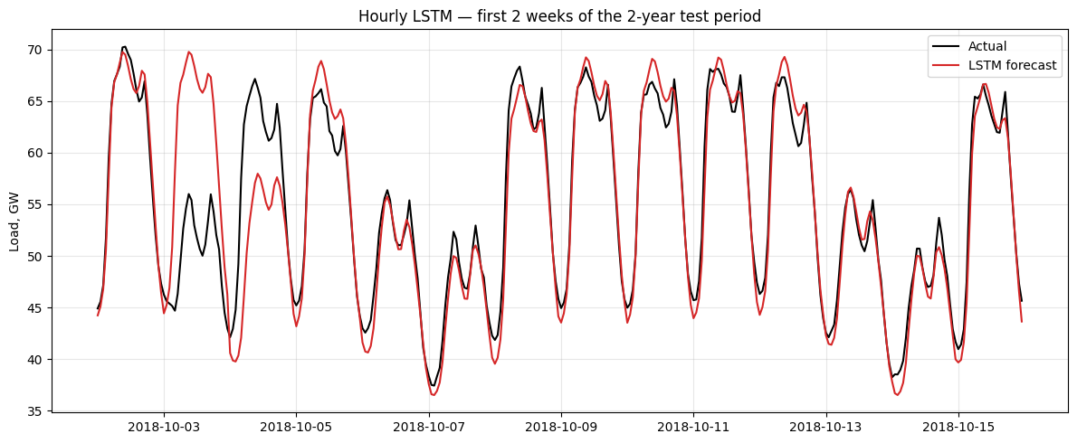
Figure 9. Hourly LSTM forecast vs. actual load, first two weeks of the test period.
Hourly: MAE = 1.591 GW, RMSE = 2.497 GW, MAPE = 2.95%; aggregated to weekly means for comparability: MAE = 0.546 GW, RMSE = 0.759 GW — the best result overall. This needs the same scrutiny as GBR, more so: the LSTM is never asked to forecast beyond 24 hours from a real starting point, re-anchored to true data daily — effectively 730 one-day-ahead forecasts rather than one 104-week-ahead forecast, an intrinsically easier task since errors cannot compound over months. The result demonstrates the network learned intraday/weekly/temperature structure well, but the leaderboard should read “best next-day forecaster, evaluated repeatedly,” not “best 2-year-ahead forecaster.”
8. Overall model comparison
Table 1 summarises all eight models using MAE, RMSE (GW), MAPE (%), MASE (error scaled by in-sample seasonal-naive error; MASE < 1 beats seasonal-naive; Hyndman & Koehler, 2006), and Bias (mean signed error).
Model | MAE (GW) | RMSE (GW) | MAPE (%) | MASE | Bias (GW)
LSTM (hourly, agg. to weekly) | 0.546 | 0.759 | 1.01 | 0.408 | -0.238
Feature model (Gradient Boosting) | 2.003 | 2.724 | 3.84 | 1.453 | 1.370
Seasonal Naive | 2.319 | 3.007 | 4.41 | 1.732 | 1.732
Naive | 3.783 | 4.459 | 6.79 | 2.827 | -0.882
Mean | 3.789 | 4.397 | 6.97 | 2.831 | 0.481
SARIMAX (temp + holiday, conditional) | 3.994 | 5.446 | 7.55 | 2.984 | 3.082
Drift | 4.340 | 5.118 | 8.05 | 3.243 | 1.007
SARIMA(3,1,6)(0,2,2)₅₂ | 5.089 | 6.622 | 9.56 | 3.802 | 4.424
Table 1. Evaluation metrics for all eight forecasting approaches, sorted by MASE (lower is better except Bias, closer to zero is better).
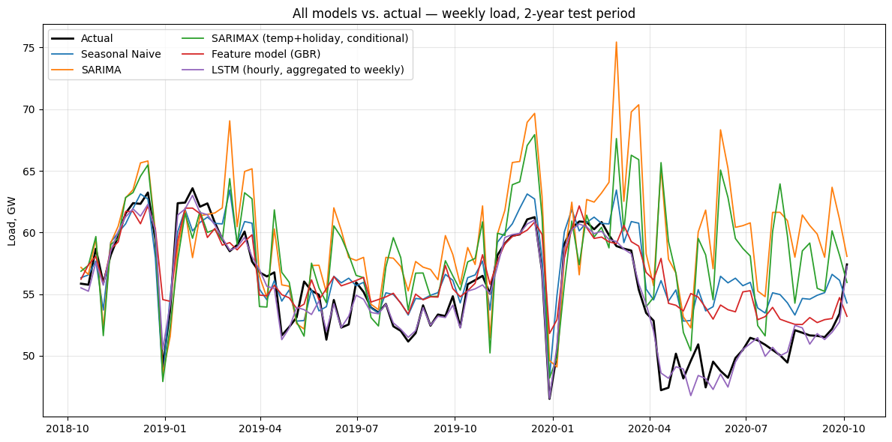
Figure 10. All model forecasts vs. actual weekly load over the two-year test period.
8.1 Forecasts vs. data collected after the modelling period
The test period (Oct 2018 – Oct 2020) includes the COVID-19 shock of spring 2020 — a sharp, roughly six-to-eight-week dip visible in Figure 10 that no pre-shock training data could anticipate, providing a genuine stress test of out-of-sample robustness. The static, single-origin forecasts (SARIMA, SARIMAX, Seasonal Naive) continue their pre-existing path straight through the shock, producing sustained error for as long as demand stays suppressed. GBR and LSTM, re-anchored to real data weekly/daily, begin tracking the reduced demand within roughly one update cycle. This is the same forecast-horizon asymmetry from Sections 6–7, now showing up as a difference in recovery speed from a genuine structural break rather than merely average error. An operational system should therefore combine a fast-reacting model (GBR/LSTM) with a longer-horizon model reserved for multi-month planning, rather than relying on either alone.
9. Answers to the set analysis questions
9.1 Q1: Compare all models against the seasonal naive benchmark. Which models, if any, provide a meaningful improvement?
Seasonal Naive (MAE 2.319 GW, RMSE 3.007 GW, MASE 1.732) is the correct baseline since it alone exploits the 52-week seasonality (STL strength 0.871). Naive, Mean, Drift, SARIMA and SARIMAX all have higher MASE (2.827–3.802) — none improves on it. GBR has MASE 1.453, a genuine 16% reduction, but given lag_52 dominates its importance ranking, this is best read as “Seasonal Naive plus a modest short-term correction,” not an independently superior model. The LSTM's MASE of 0.408 is an order-of-magnitude improvement but is not an apples-to-apples comparison: it is re-anchored to real data every 24 hours (730 one-day-ahead forecasts) rather than committing to one 104-week horizon. Overall: only the GBR provides a genuinely comparable improvement at the same horizon; the LSTM's gain is real but partly an artefact of an easier task.
9.2 Q2: Explain how you avoided data leakage when creating temperature lag features.
Two risks were addressed. Within-week leakage: daily Berlin temperature was aggregated with resample('W-SUN').mean()/.min()/.max()/.sum(), which only aggregates days inside week t. Load-feature leakage: all lag/rolling predictors for GBR used .shift(1) before any rolling window, so week t's row never contains week-t load. However, no lagged temperature features were created — the temperature/degree-day values used at test time are the actual, contemporaneous values for the forecast week itself, not a forecast made in advance. This does not leak future weeks into earlier ones, but does give the model information (this week's true weather) unavailable at a genuine forecast-issue moment — the more consequential, operational-validity issue (see Q4).
9.3 Q3: For the SARIMAX model, justify the chosen differencing orders and seasonal period.
- Seasonal period s = 52: well justified — STL seasonality strength 0.871 and a clean 52-week ACF ripple (Figure 4) make an annual period, expressed in weekly steps, the natural choice.
- d = 1: reasonably justified — STL trend strength was modest (0.383) and ADF/KPSS agreed the level is already stationary, but (3,1,6) had the lowest Stage-1 AIC (303.36) among 144 converged candidates.
- D = 2: not justified — the weak point in the specification. Two seasonal differences remove 104 of 197 points, leaving ≈93 effective points for an 11-parameter structure, producing infinite z-statistics, a singular covariance matrix and a spuriously low AIC (24.00 vs. 127+ for D = 1 candidates) that rewards a numerically degenerate fit. Residual Ljung-Box at lag 52 (p = 2.8×10⁻¹⁰) confirms the seasonal component is still not whitened. A defensible choice, given ∼3.8 years of data, would cap D at 1.
9.4 Q4: Evaluate whether temperature and holiday covariates improve forecast accuracy. Are these covariates known at the forecast origin?
Temperature measurably helps in SARIMAX (RMSE 6.622 → 5.446 GW, −18%) with an intuitive heating-degree-day coefficient (+0.063), but contributes little in GBR (temp_max importance 0.025, versus 0.558 for lag_52) — weather-correlated variation is already captured indirectly via lagged load and calendar terms. Holiday features show negligible benefit in either model (SARIMAX coefficients collapse to zero; GBR holiday features rank outside the top ten), likely because one holiday inside a seven-day week is averaged away at weekly resolution.
Known at origin? Holiday dates are fixed years in advance, so they are genuinely known at any forecast origin — their weak importance reflects weekly-resolution averaging, not unavailability. Temperature is the opposite: values used at test time are realised, historical temperatures for weeks that, from an October-2018 forecast origin, had not yet happened. An operational system would need a genuine weather forecast, reliable for at most ≈ 2 weeks — so for most of the two-year horizon no legitimate temperature covariate could exist at the true origin. Reported temperature gains should be read as an upper bound, not an achievable operational improvement.
9.5 Q5: Compare the interpretability and complexity of SARIMAX, feature-based, and neural network models.
- SARIMAX is nominally most interpretable (explicit, explainable coefficients) but here the covariance matrix is singular and standard errors meaningless — numbers can be quoted but not statistically trusted. Moderate fitting cost, but the order-search behind it (171 candidates, ≈2h) is expensive and fragile.
- GBR has no native coefficients, but permutation importance gives a faithful, easy global story (lag_52 and lag_1 dominate). More complex to engineer than SARIMAX but cheap and fast to retrain (seconds).
- LSTM is least interpretable — gated weights have no physical meaning and would need SHAP/attention-style tooling to explain. Most complex to build/maintain: hyperparameter search, careful scaling, bespoke windowing, and the largest data volume (50,400 hourly rows).
The classic accuracy–interpretability–complexity trade-off holds, with a twist: SARIMAX's superior nominal interpretability is undermined by a broken estimation, so GBR is arguably both more trustworthy to interpret and less complex to maintain here, even though SARIMAX is the more transparent model type in principle.
9.6 Q6: Recommend one model for operational use and justify your choice using accuracy, uncertainty, interpretability, and maintenance considerations.
Weighing accuracy, uncertainty, interpretability and maintenance, the Gradient Boosting Regressor is recommended as the primary model for an operational weekly demand-forecasting system, over the LSTM despite its lower raw error, and over SARIMA/SARIMAX in their current form.
- Accuracy: a genuine improvement over Seasonal Naive (MASE 1.453 vs. 1.732) at a weekly re-anchored cadence matching realistic utility practice, unlike SARIMA/SARIMAX's fragile single 104-week commitment.
- Uncertainty: the GBR's weakest dimension — point forecasts only, versus SARIMAX's (unreliable) analytic CIs. A fixable gap via quantile regression or conformal prediction (Section 10), and the first enhancement before deployment.
- Interpretability: permutation importance gives a clear, auditable story, arguably more trustworthy than SARIMAX's numerically singular coefficients and far more transparent than the LSTM.
- Maintenance: retrains in seconds with no GPU and a small hyperparameter surface, versus the LSTM's architecture search or SARIMA's expensive, unreliable AIC-driven order search.
The LSTM should not be dismissed: its next-day accuracy suits short-horizon dispatch/balancing decisions. A sensible architecture pairs GBR for week-to-month-ahead planning with the LSTM for next-day dispatch, while SARIMA/SARIMAX are held back from production until the differencing order is corrected and uncertainty estimates can be trusted.
10. Limitations and future improvements
- Fix SARIMA order selection before trusting it: cap D at 1 given under four annual cycles of training data, discard singular-covariance candidates, and prefer BIC over AIC for this class of high-order seasonal model (Hyndman & Athanasopoulos, 2021).
- Replace the conditional weather input with a genuine day/week-ahead forecast and re-evaluate SARIMAX/GBR/LSTM under that harder, realistic setting; current RMSEs are a best case, not an operational one.
- Put every model on equal footing: either give SARIMA/SARIMAX rolling weekly re-estimation, or restrict GBR/LSTM to a single static long-horizon forecast, resolving the current apples-to-oranges horizon comparison.
- Extend the comparison with a direct multi-step architecture (e.g. a Temporal Fusion Transformer, Lim et al., 2021) that natively handles long horizons and multiple seasonalities without 24-hour re-anchoring.
- Add explicit COVID-period or regime-switch/intervention terms, standard in post-2020 load-forecasting literature, so models are not penalised for an unforecastable shock.
- Investigate the counter-intuitive negative cooling-degree-day coefficient, e.g. by interacting degree-days with a summer-holiday indicator, to separate genuine cooling load from confounded holiday effects.
- Quantify GBR/LSTM forecast uncertainty (quantile regression, conformal prediction, or MC-dropout) to match SARIMA/SARIMAX's confidence intervals.
11. Conclusion
Across eight models, the test-set ranking was: LSTM (hourly, aggregated) > GBR > Seasonal Naive > Naive ≈ Mean > SARIMAX > Drift > SARIMA. Taken at face value this looks like sophistication simply paying off. The more useful reading is that the ranking is driven at least as much by how much true, recent information each model is allowed to use at forecast time as by genuine modelling capability: SARIMA/SARIMAX commit to one long, uninterrupted forecast and are penalised heavily — SARIMA additionally suffers from a genuinely broken, over-differenced specification chosen by an unguarded AIC search — while GBR and especially the LSTM are re-anchored to real data every week or day and consequently solve an easier problem. This does not make the strong results illegitimate; it means they should be reported, and acted on, with the caveat attached, and it is this critical reading — not the raw metrics in Table 1 alone — that should guide model choice for an actual deployment.
References
- Bouktif, S., Fiaz, A., Ouni, A., & Serhani, M. A. (2018). Optimal Deep Learning LSTM Model for Electric Load Forecasting Using Feature Selection and Genetic Algorithm. Energies, 11(7), 1636.
- Cleveland, R. B., Cleveland, W. S., McRae, J. E., & Terpenning, I. (1990). STL: A Seasonal-Trend Decomposition Procedure Based on Loess. Journal of Official Statistics, 6(1), 3–73.
- Hochreiter, S., & Schmidhuber, J. (1997). Long Short-Term Memory. Neural Computation, 9(8), 1735–1780.
- Hyndman, R. J., & Koehler, A. B. (2006). Another look at measures of forecast accuracy. International Journal of Forecasting, 22(4), 679–688.
- Kong, W., Dong, Z. Y., Jia, Y., Hill, D. J., Xu, Y., & Zhang, Y. (2019). Short-Term Residential Load Forecasting Based on LSTM Recurrent Neural Network. IEEE Trans. Smart Grid, 10(1), 841–851.
- Lim, B., Arık, S. Ö., Loeff, N., & Pfister, T. (2021). Temporal Fusion Transformers for interpretable multi-horizon time series forecasting. International Journal of Forecasting, 37(4), 1748–1764.
- Open Power System Data (2020). Time series, Version 2020-10-06. data.open-power-system-data.org/time_series/2020-10-06
- Open-Meteo (2024). Historical Weather API documentation. open-meteo.com/en/docs/historical-weather-api

